**EXPERIMENT – 1**

**Aim:**

To study various DDL commands – CREATE

1. CREATE DATABASE Bank_details ;

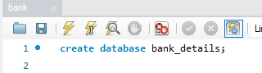

1. CREATE TABLE DEPOSIT (

ACTNO VARCHAR(5) PRIMARY KEY CHECK (ACTNO LIKE 'D%'),

CNAME VARCHAR(15) REFERENCES CUSTOMER(CNAME),

BNAME VARCHAR(20) REFERENCES BRANCH(BNAME),

AMOUNT DECIMAL(8,2) NOT NULL CHECK (AMOUNT > 0),

ADATE DATE

);

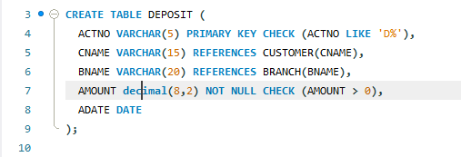



1. CREATE TABLE CUSTOMER (

CNAME VARCHAR(15) PRIMARY KEY,

CITY VARCHAR(30) NOT NULL

);

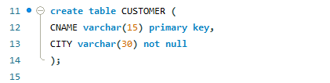



1. CREATE TABLE BRANCH (

BNAME VARCHAR(20) PRIMARY KEY,

CITY VARCHAR(30) CHECK(CITY IN ('NAGPUR','DELHI',

'BANGLORE','BOMBAY'))NOT NULL

);

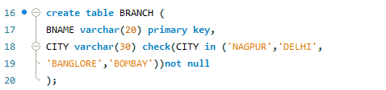



1. CREATE TABLE BORROW (

LOANNO VARCHAR(8) check(LOANNO like 'L%') primary key,

CNAME VARCHAR(15) REFERENCES CUSTOMER(CNAME),

BNAME VARCHAR(20) REFERENCES BRANCH(BNAME),

AMOUNT FLOAT(8) NOT NULL CHECK (AMOUNT > 0)

);

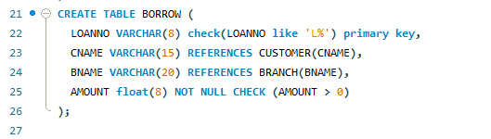



**INSERTION OF VALUES**

1. **Inserting values to CUSTOMER**

INSERT INTO CUSTOMER (CNAME, CITY) VALUES ('ANIL', 'CALCUTTA');

INSERT INTO CUSTOMER (CNAME, CITY) VALUES ('SUNIL', 'DELHI');

INSERT INTO CUSTOMER (CNAME, CITY) VALUES ('MEHUL', 'BARODA');

INSERT INTO CUSTOMER (CNAME, CITY) VALUES ('MANDAR', 'PATNA');

INSERT INTO CUSTOMER (CNAME, CITY) VALUES ('MADHURI', 'NAGPUR');

INSERT INTO CUSTOMER (CNAME, CITY) VALUES ('PRAMOD', 'NAGPUR');

INSERT INTO CUSTOMER (CNAME, CITY) VALUES ('SANDIP', 'SURAT');

INSERT INTO CUSTOMER (CNAME, CITY) VALUES ('SHIVANI', 'BOMBAY');

INSERT INTO CUSTOMER (CNAME, CITY) VALUES ('KRANTI', 'BOMBAY');

INSERT INTO CUSTOMER (CNAME, CITY) VALUES ('NAREN', 'BOMBAY');

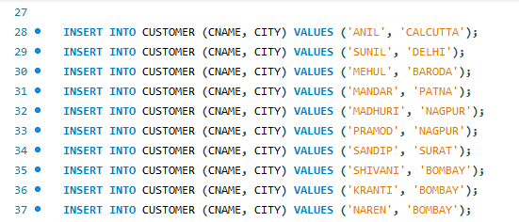

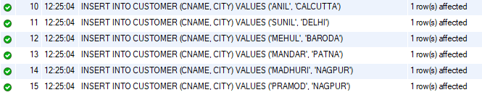 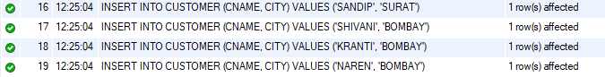

1. **Inserting values to BRANCH**

INSERT INTO BRANCH (BNAME, CITY) VALUES ('VRCE', 'NAGPUR');

INSERT INTO BRANCH (BNAME, CITY) VALUES ('AJNI', 'NAGPUR');

INSERT INTO BRANCH (BNAME, CITY) VALUES ('KAROLBAGH', 'DELHI');

INSERT INTO BRANCH (BNAME, CITY) VALUES ('CHANDNI', 'DELHI');

INSERT INTO BRANCH (BNAME, CITY) VALUES ('DHARAMPETH', 'NAGPUR');

INSERT INTO BRANCH (BNAME, CITY) VALUES ('MG ROAD', 'BANGLORE');

INSERT INTO BRANCH (BNAME, CITY) VALUES ('ANDHERI', 'BOMBAY');

INSERT INTO BRANCH (BNAME, CITY) VALUES ('NEHRU PALACE', 'DELHI');

INSERT INTO BRANCH (BNAME, CITY) VALUES ('POWAI', 'BOMBAY');

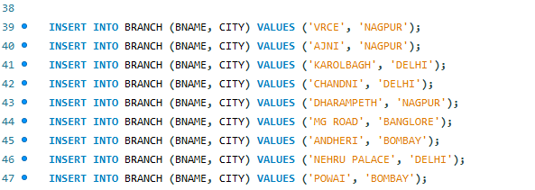

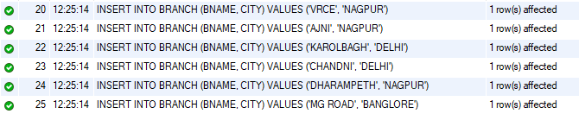 

1. **Inserting values to BORROW**

INSERT INTO borrow (LOANNO, CNAME, BNAME, AMOUNT)

VALUES ('L201', 'ANIL', 'VRCE', 1000.00);

INSERT INTO borrow (LOANNO, CNAME, BNAME, AMOUNT)

VALUES ('L206', 'MEHUL', 'AJNI', 5000.00);

INSERT INTO borrow (LOANNO, CNAME, BNAME, AMOUNT)

VALUES ('L311', 'SUNIL', 'DHARAMPETH', 3000.00);

INSERT INTO borrow (LOANNO, CNAME, BNAME, AMOUNT)

VALUES ('L321', 'MADHURI', 'ANDHERI', 2000.00);

INSERT INTO borrow (LOANNO, CNAME, BNAME, AMOUNT)

VALUES ('L371', 'PRAMOD', 'VIRAR', 8000.00);

INSERT INTO borrow (LOANNO, CNAME, BNAME, AMOUNT)

VALUES ('L481', 'KRANTI', 'NEHRU PLACE', 3000.00);

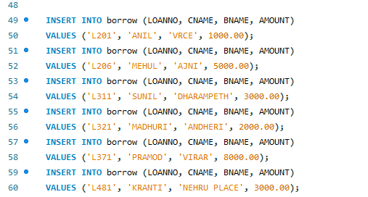

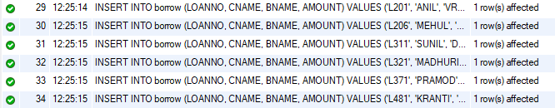

1. **Inserting values to DEPOSIT**

INSERT INTO Deposit (ACTNO, CNAME, BNAME, AMOUNT, ADATE)

VALUES ('D100', 'ANIL', 'VRCE', 1000.00, '1995-03-01');

INSERT INTO Deposit (ACTNO, CNAME, BNAME, AMOUNT, ADATE)

VALUES ('D101', 'SUNIL', 'ANJNI', 500.00, '1996-01-04');

INSERT INTO Deposit (ACTNO, CNAME, BNAME, AMOUNT, ADATE)

VALUES ('D102', 'MEHUL', 'KAROLBAGH', 3500.00, '1995-11-17');

INSERT INTO Deposit (ACTNO, CNAME, BNAME, AMOUNT, ADATE)

VALUES ('D104', 'MADHURI', 'CHANDNI', 1200.00, '1995-12-17');

INSERT INTO Deposit (ACTNO, CNAME, BNAME, AMOUNT, ADATE)

VALUES ('D105', 'PRAMOD', 'MG ROAD', 3000.00, '1996-03-27');

INSERT INTO Deposit (ACTNO, CNAME, BNAME, AMOUNT, ADATE)

VALUES ('D106', 'SANDIP', 'ANDHERI', 2000.00, '1996-03-31');

INSERT INTO Deposit (ACTNO, CNAME, BNAME, AMOUNT, ADATE)

VALUES ('D107', 'SHIVANI', 'VIRAR', 1000.00, '1995-09-05');

INSERT INTO Deposit (ACTNO, CNAME, BNAME, AMOUNT, ADATE)

VALUES ('D108', 'KRANTI', 'NEHRU PLACE', 5000.00, '1995-07-02');

INSERT INTO Deposit (ACTNO, CNAME, BNAME, AMOUNT, ADATE)

VALUES ('D109', 'MINU', 'POWAI', 7000.00, '1995-08-10');

